**Supporting Information**

Title: The Development and Application of KinomePro-DL: A Deep Learning Based Online Small Molecule Kinome Selectivity Profiling Prediction Platform

*Wei Ma, Jiaqi Hu, Zhuangzhi Chen, Yaoqin Ai, Yihang Zhang, Keke Dong, Xiangfei Meng, and Liu Liu\**

Drug Research Business Unit, PharmaBlock Sciences (Nanjing), Inc., 81 Huasheng Road, Jiangbei New Area, Nanjing, Jiangsu, 210032, China.

* Correspondence Email: liu_liu@PharmaBlock.com

The Supporting Materials file includes ：

**Figure S1:** Kinome selectivity profile maps of 15 compounds from internal collection obtained from Eurofin KINOMEscan (left column) and predicted by KinomeX (right column).

**Figure S2:** Kinome selectivity profile maps of 15 compounds from internal collection obtained from Eurofin KINOMEscan (left column) and predicted by AMGU Model (right column).

**Figure S3:** Kinome selectivity profile maps of 15 compounds from internal collection obtained from Eurofin KINOMEscan (left column) and predicted by KinScan Model (right column).

**Table S1:** Structural information for the eight test compounds

**Table S2:** Compound purity information

**Figure S4:** Comparison of the kinome selectivity profiles predicted by KinomePro-DL model and experimental results obtain from Eurofin KINOMEscan of Molecule 18.

**Figure S5:** Structures of known CDK2 inhibitors from ChemEMBL database with highest similarity compared to hit compounds 11 (a) and 18 (b). Numbers listed for each compound were similarity values obtained by molecular fingerprints using RDKit.

**Figure S6:** Screenshots of representative webpages of KinomePro-DL web server tool, including Homepage, Single molecule prediction, Batch prediction, Fine-tuning, Finetuned Prediction module, and Prediction by manually drawing structures.

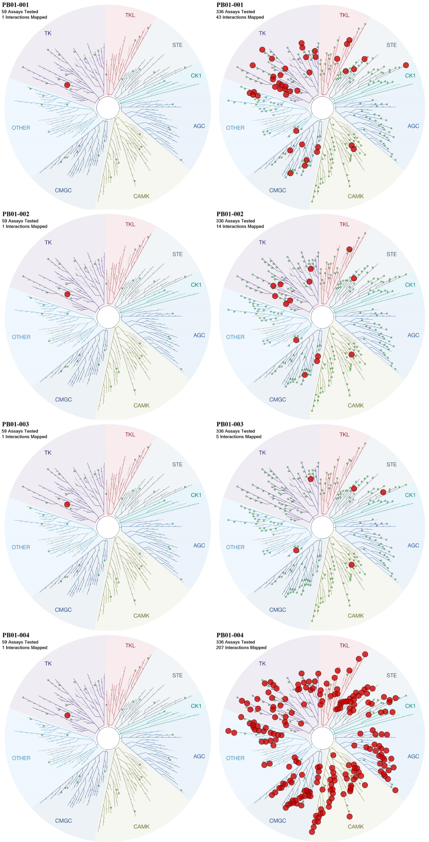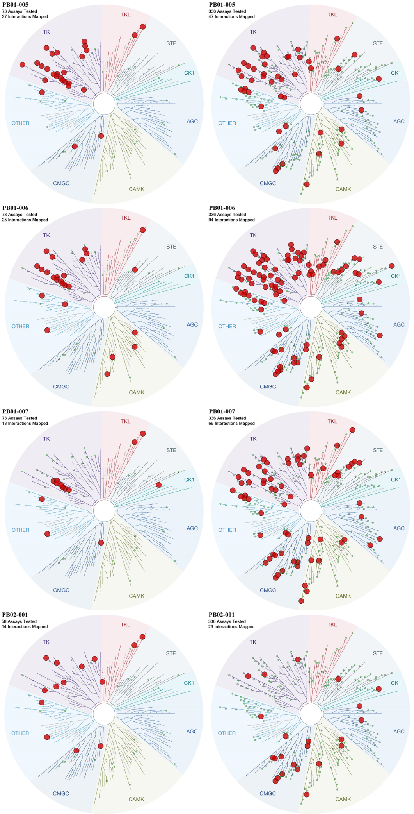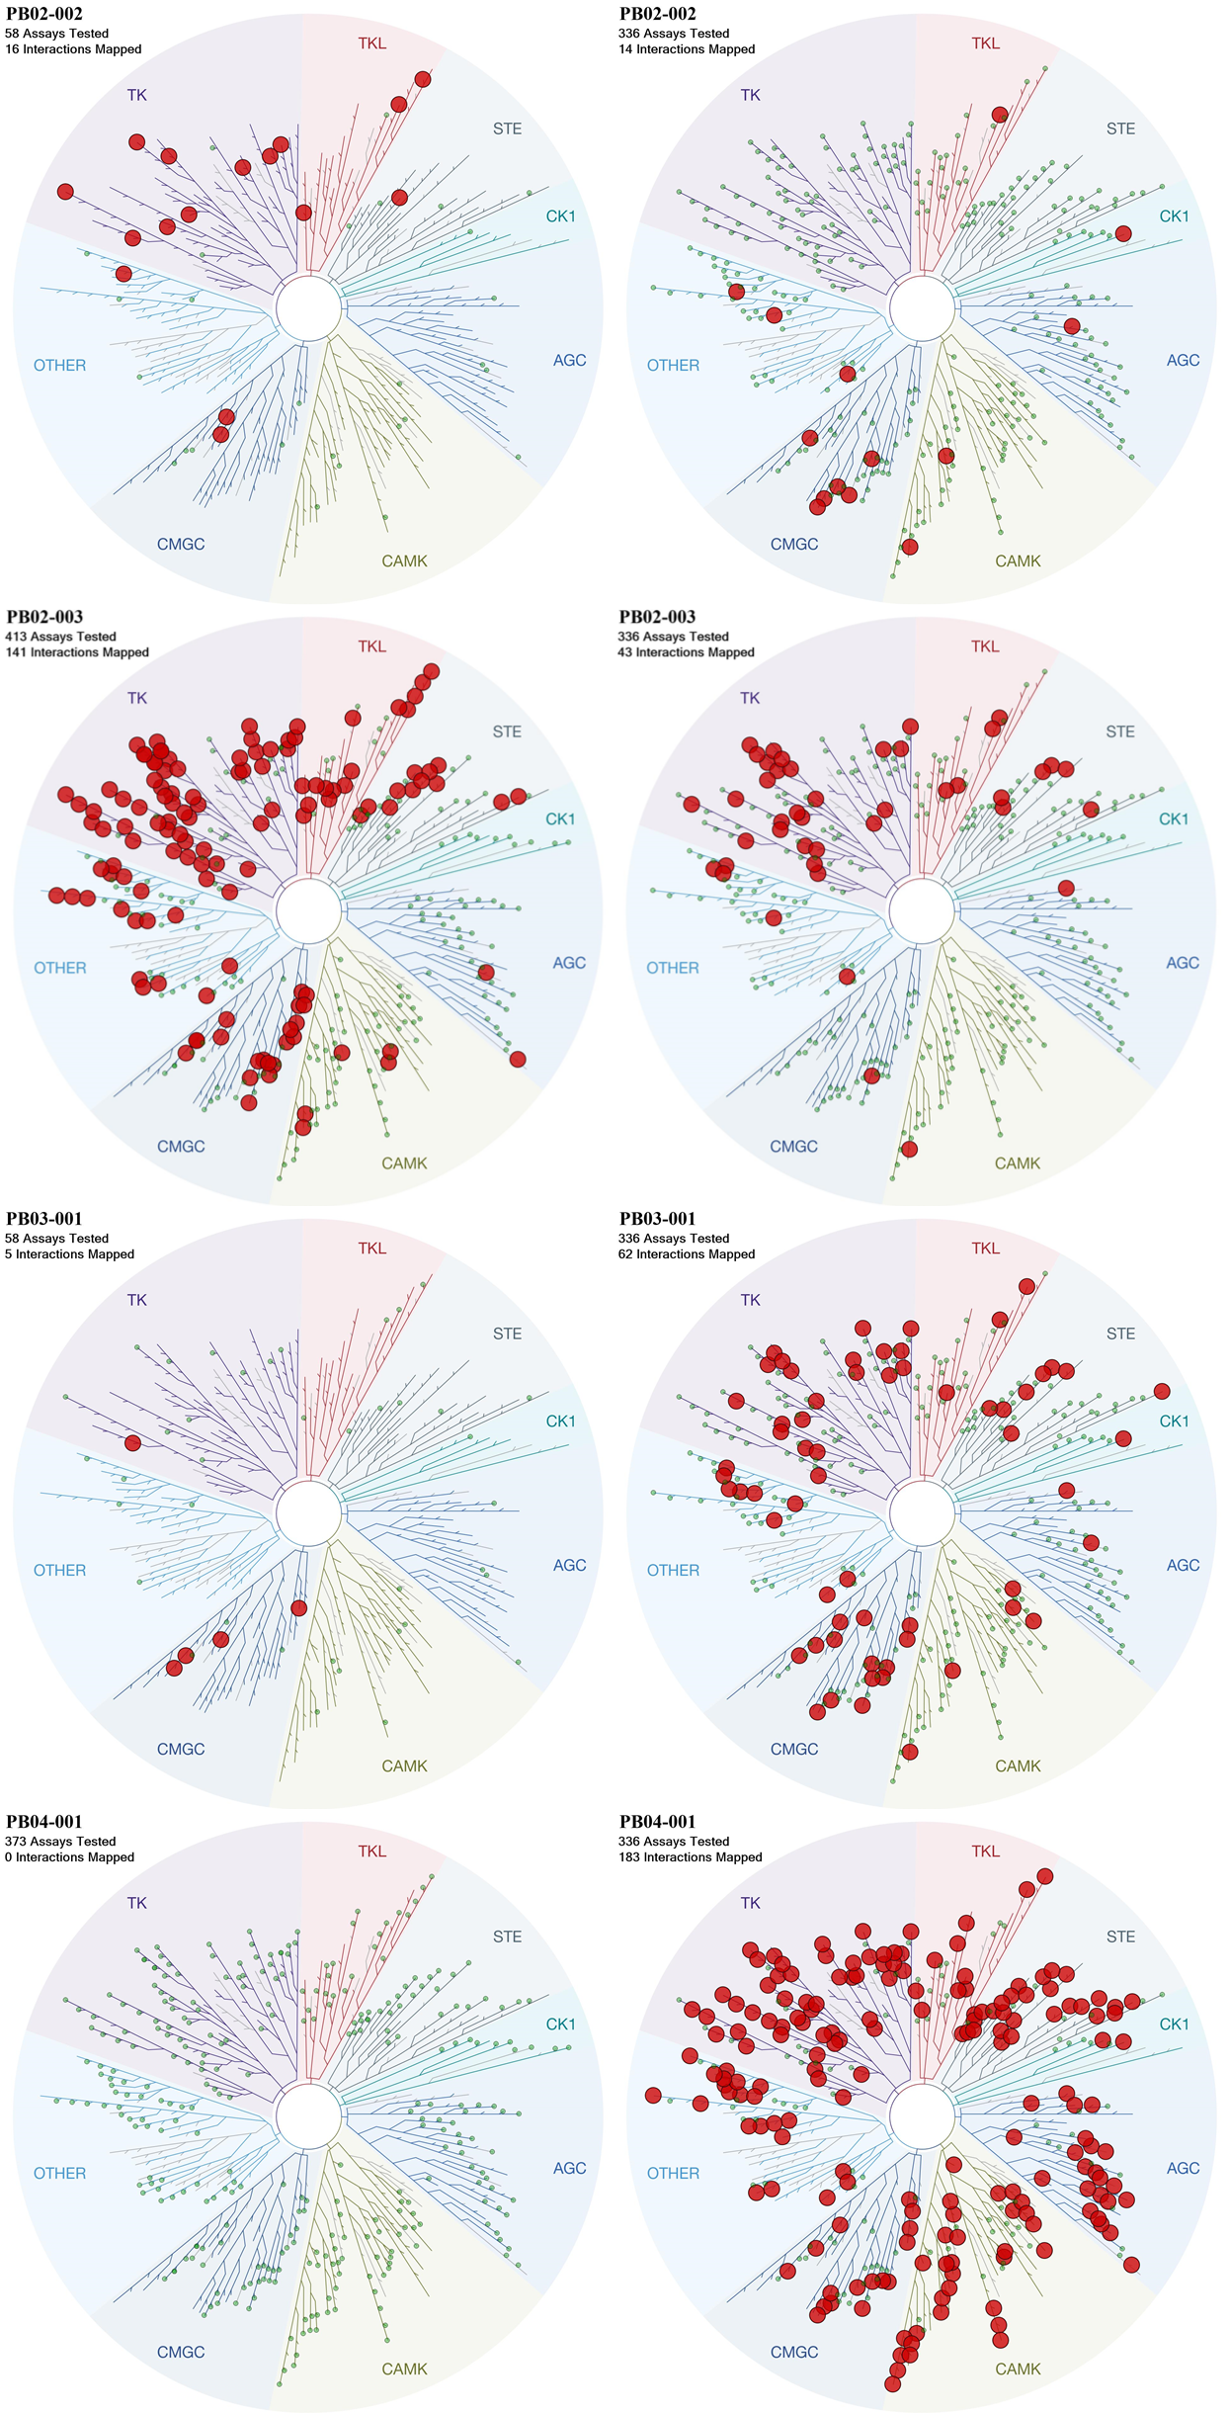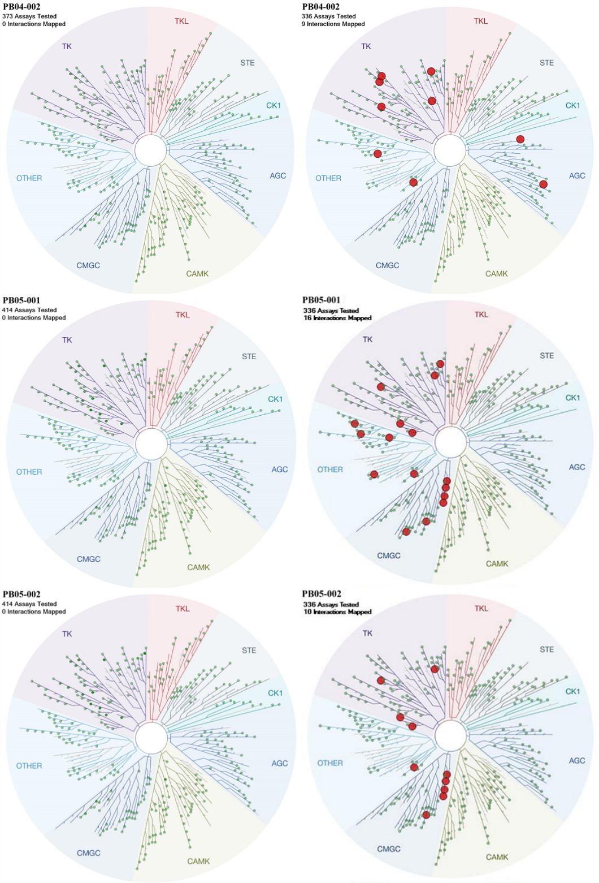

**Figure S1:** Kinome selectivity profile maps of 15 compounds from internal collection obtained from Eurofin KINOMEscan (left column) and predicted by KinomeX (right column).

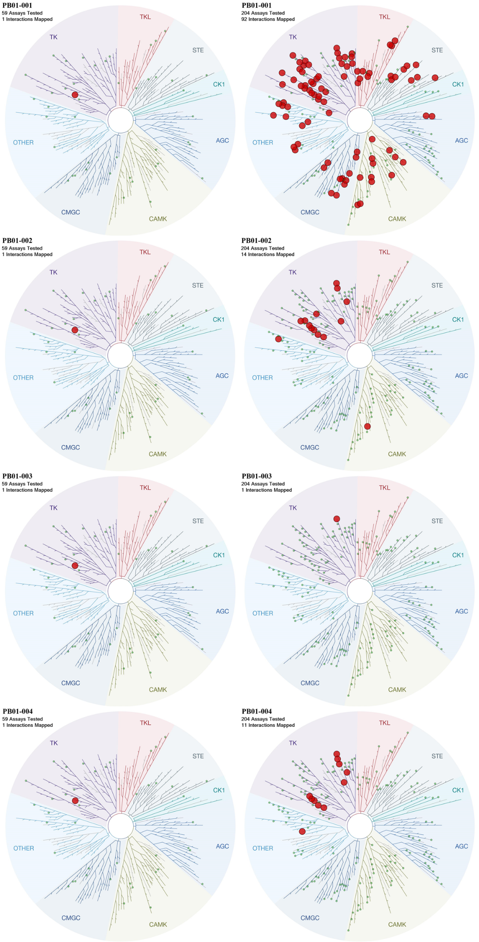

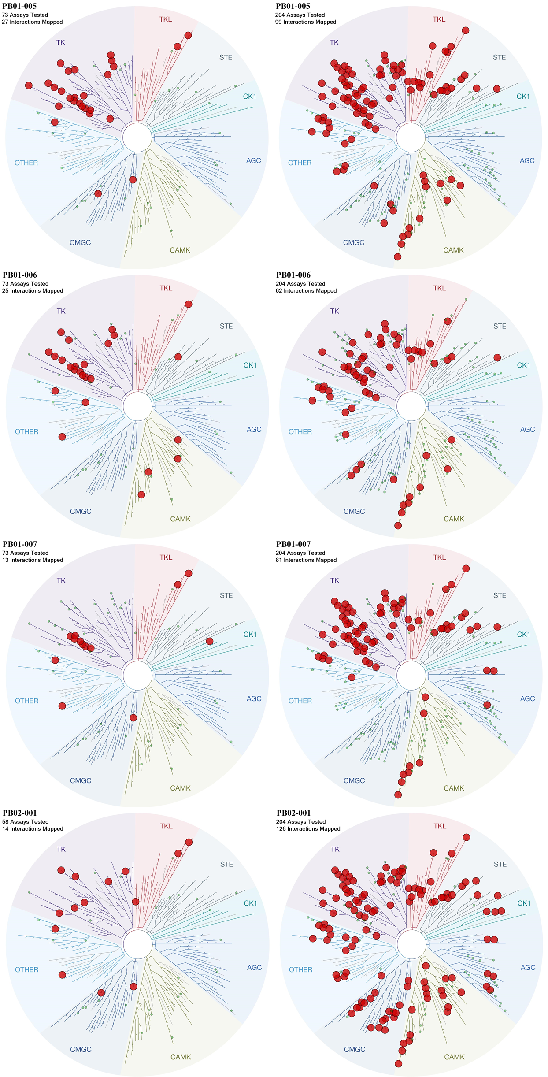

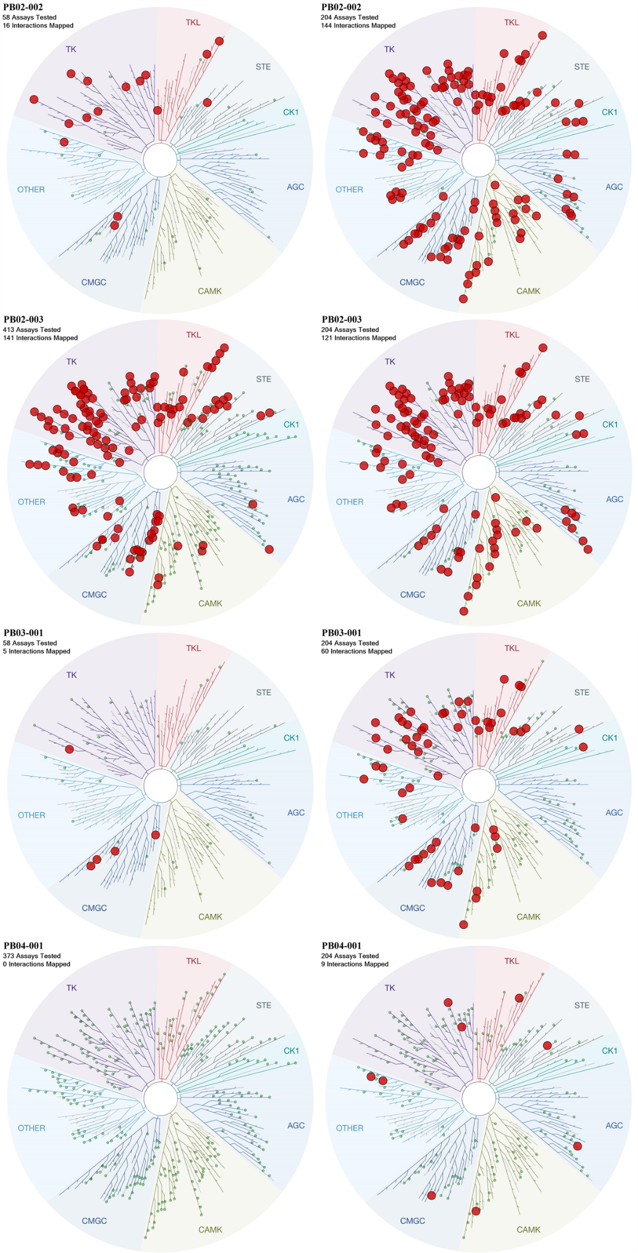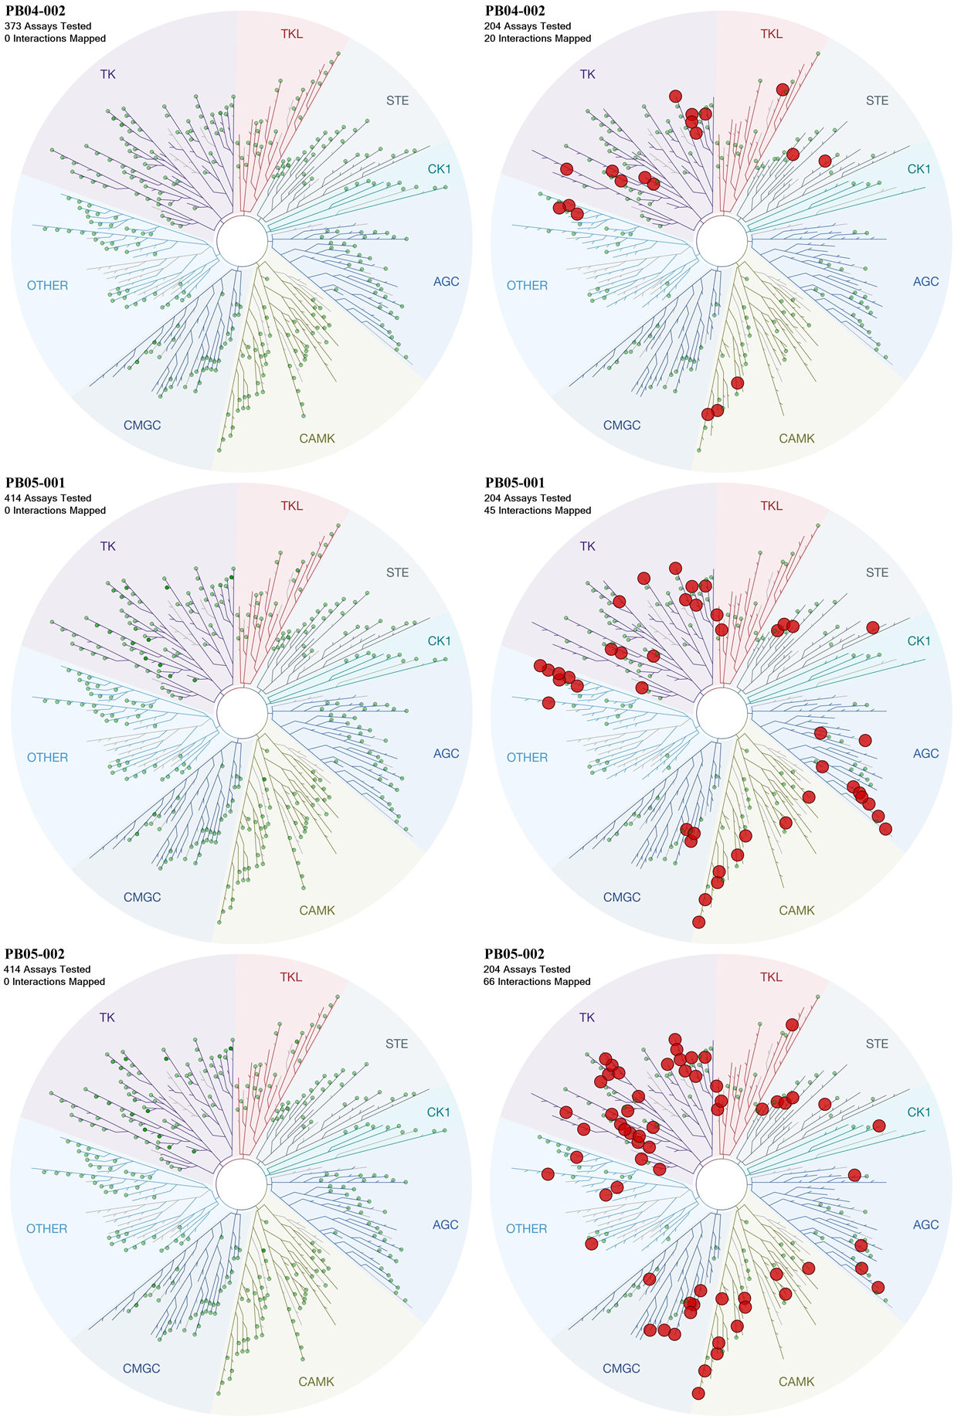

**Figure S2:** Kinome selectivity profile maps of 15 compounds from internal collection obtained from Eurofin KINOMEscan (left column) and predicted by AMGU Model (right column).

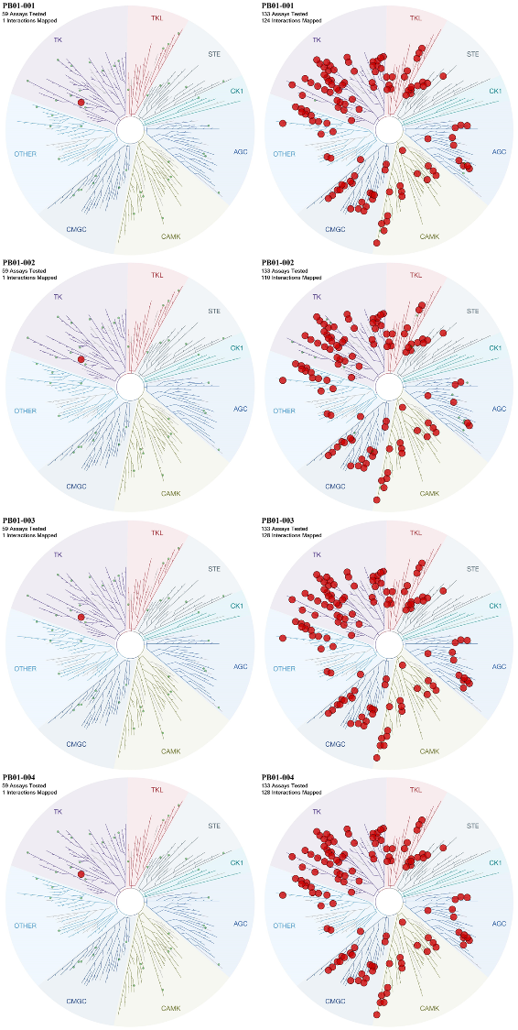

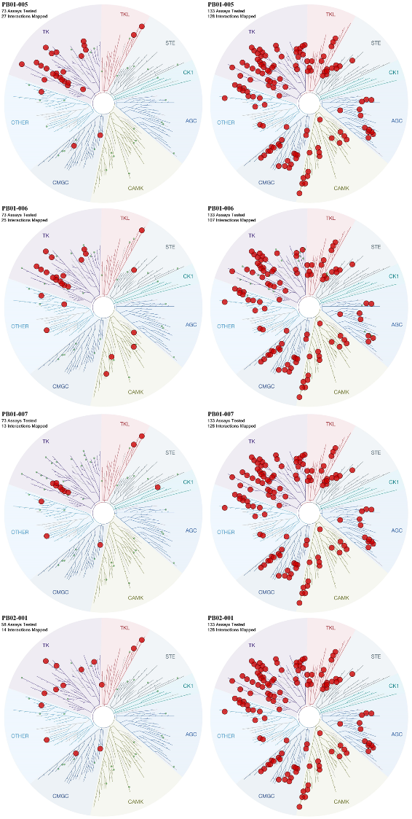

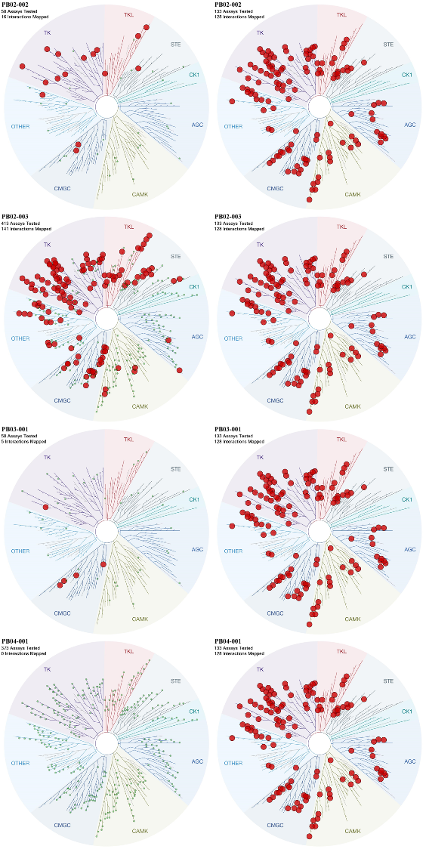

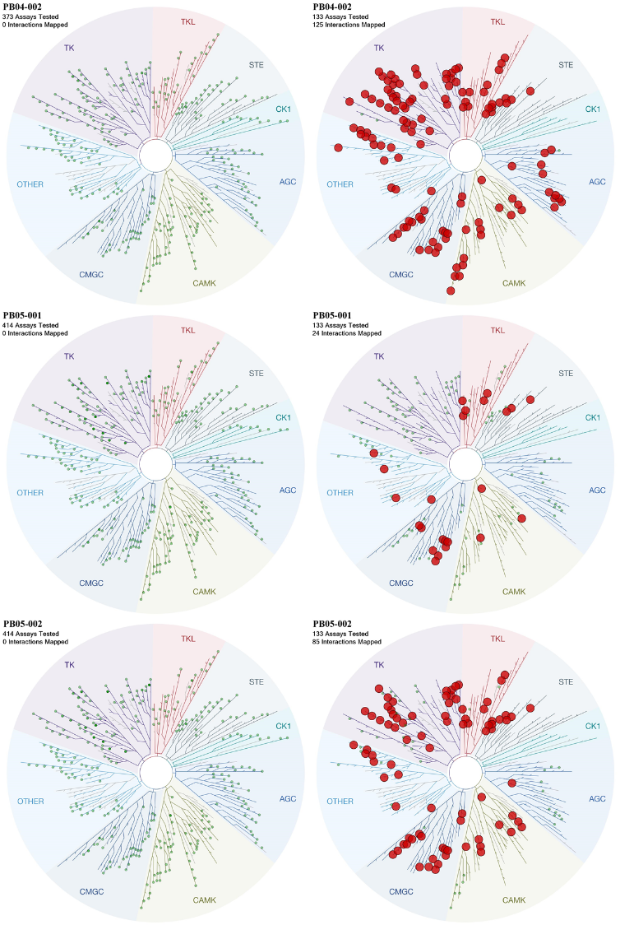

**Figure S3:** Kinome selectivity profile maps of 15 compounds from internal collection obtained from Eurofin KINOMEscan (left column) and predicted by KinScan Model (right column).

**Table S1:** Structural information for the eight test compounds

|  |  |
| --- | --- |
| Compound | smiles |
| Molecule-10 | [H]N(C1=NC=C(CN2CCOCC2)C=C1)[C@]1([H])CCC2=C1C=CC=C2 |
| Molecule-11 | O=C(N1)C(C2=C(S3)CCCCC2)=C3N=C1CC4=CNN=C4 |
| Molecule-17 | FC1=CC=CC(C2=NC=NC(NC3C[C@@H]4CC[C@@H](N4S(C)(=O)=O)C3)=N2)=C1 |
| Molecule-18 | O=C(CC1=CC=C2C=NNC2=C1)NC3=NNC(C4CCOCC4)=C3 |
| Molecule-20 | O[C@@H]1C[C@H]2C[C@@H]1CC2CNC(NC3=NC=C(C4CCOCC4)S3)=O |
| Molecule-21 | [H]N(C(=O)C[C@]1([H])CCC2=C(C1)C=CC=C2)C1=NN([H])C(=C1)C1([H])CCOCC1 |
| Molecule-23 | [H]N([H])S(=O)(=O)C1=CC=C(C=C1)C1=NC2=CC=C(C=C2C(=O)N1[H])C([H])(C)C |
| Molecule-25 | [H]N(C[C@]1(C)CCOC1)C(=O)N([H])C1=NC=C(S1)C1([H])CCOCC1 |

**Table S2:** Compound purity information

|  |  |  |  |
| --- | --- | --- | --- |
| Compound Name | IUPAC Name | HPLC analysis (retention time/min) | HPLC analysis (peak area) |
| Molecule 10 | (R)-N-(2,3-dihydro-1H-inden-1-yl)-5-(morpholinomethyl)pyridin-2-amine | 0.554 | 100% |
| Molecule11 | 2-((1H-pyrazol-4-yl)methyl)-3,5,6,7,8,9-hexahydro-4H-cyclohepta[4,5]thieno[2,3-d]pyrimidin-4-one | 0.894 | 100% |
| Molecule17 | (1R,3s,5S)-N-(4-(3-fluorophenyl)-1,3,5-triazin-2-yl)-8-(methylsulfonyl)-8-azabicyclo[3.2.1]octan-3-amine | 1.239 | 100% |
| Molecule18 | 2-(1H-indazol-6-yl)-N-(5-(tetrahydro-2H-pyran-4-yl)-1H-pyrazol-3-yl)acetamide | 0.958 | 97.4% |
| Molecule20 | 1-(((1R,2R,4R,5R)-5-hydroxybicyclo[2.2.1]heptan-2-yl)methyl)-3-(5-(tetrahydro-2H-pyran-4-yl)thiazol-2-yl)urea | 1.066 | 100% |
| Molecule21 | (R)-N-(5-(tetrahydro-2H-pyran-4-yl)-1H-pyrazol-3-yl)-2-(1,2,3,4-tetrahydronaphthalen-2-yl)acetamide | 1.089 | 100% |
| Molecule23 | 4-(6-isopropyl-4-oxo-3,4-dihydroquinazolin-2-yl)benzenesulfonamide | 1.193 | 95.33% |
| Molecule25 | (S)-1-((3-methyltetrahydrofuran-3-yl)methyl)-3-(5-(tetrahydro-2H-pyran-4-yl)thiazol-2-yl)urea | 0.924 | 100% |
| PB01-001 | 4-((2-(((1R,2R)-2-hydroxycyclohexyl)amino)benzo[d]thiazol-6-yl)oxy)-N-methylpicolinamide | —— | 99% |
| PB01-002 | 4-(3-methoxy-4-((4-methoxybenzyl)oxy)phenoxy)-N-methylpicolinamide | —— | 95% |
| PB01-003 | 5-(3-methoxy-4-((4-methoxybenzyl)oxy)benzyl)pyrimidine-2,4-diamine | —— | 97% |
| PB01-004 | 4-((5-methoxy-6-((5-methoxypyridin-2-yl)methoxy)pyridin-3-yl)methyl)-2-(1-methyl-1H-pyrazol-4-yl)pyrimidine | —— | 97% |
| PB01-005 | N-(4-((2-((1-ethyl-3,3-dimethyl-2-oxoindolin-5-yl)amino)-5-methylpyrimidin-4-yl)oxy)-2-methylphenyl)acetamide | —— | 97% |
| PB01-006 | 1-ethyl-5-((4-methoxy-5-methylpyrimidin-2-yl)amino)-3,3-dimethylindolin-2-one | —— | 99.67% |
| PB01-007 | 4-((2-acetyl-1,2,3,4-tetrahydroisoquinolin-6-yl)oxy)-2-((4-(tert-butyl)phenyl)amino)-7H-pyrrolo[2,3-d]pyrimidine-5-carbonitrile | —— | 90% |
| PB02-001 | 2-((6-(7-acetyl-2,7-diazaspiro[3.5]nonan-2-yl)-2-(pyridin-3-yl)pyrimidin-4-yl)amino)isonicotinonitrile | —— | 99.06% |
| PB02-002 | 1-(2-(6-((4-ethylpyridin-2-yl)amino)-2-(pyridin-3-yl)pyrimidin-4-yl)-2,7-diazaspiro[3.5]nonan-7-yl)ethan-1-one | —— | 99.22% |
| PB02-003 | 1-(2-(2-(1-(2-hydroxy-2-methylpropyl)-1H-pyrazol-4-yl)-6-((4-(trifluoromethoxy)pyridin-2-yl)amino)pyrimidin-4-yl)-2-azaspiro[3.4]octan-6-yl)ethan-1-one | —— | 97% |
| PB03-001 | (R)-N-((5,5-difluoro-1-(3-methyl-6-((4-(trifluoromethyl)pyridin-2-yl)amino)picolinoyl)piperidin-2-yl)methyl)acetamide | —— | 94.71% |
| PB04-001 | N-(4-bromo-2,5-difluorophenyl)-6-chloro-1H-pyrrolo[2,3-b]pyridine-3-sulfonamide | —— | 95% |
| PB04-002 | N-(4-bromo-2,5-difluorophenyl)-6-methyl-7-oxo-6,7-dihydro-1H-pyrrolo[2,3-c]pyridine-3-sulfonamide | —— | 95% |
| PB05-001 | 2-((1R,5S,6R)-3-(2-((S)-2-methylazetidin-1-yl)-6-(trifluoromethyl)pyrimidin-4-yl)-3-azabicyclo[3.1.0]hexan-6-yl)acetic acid | —— | 97% |
| PB05-002 | 2-(3-(2-((S)-2-methylazetidin-1-yl)-6-(trifluoromethyl)pyrimidin-4-yl)-2-oxo-3-azabicyclo[3.1.0]hexan-6-yl)acetic acid | —— | 97.61% |

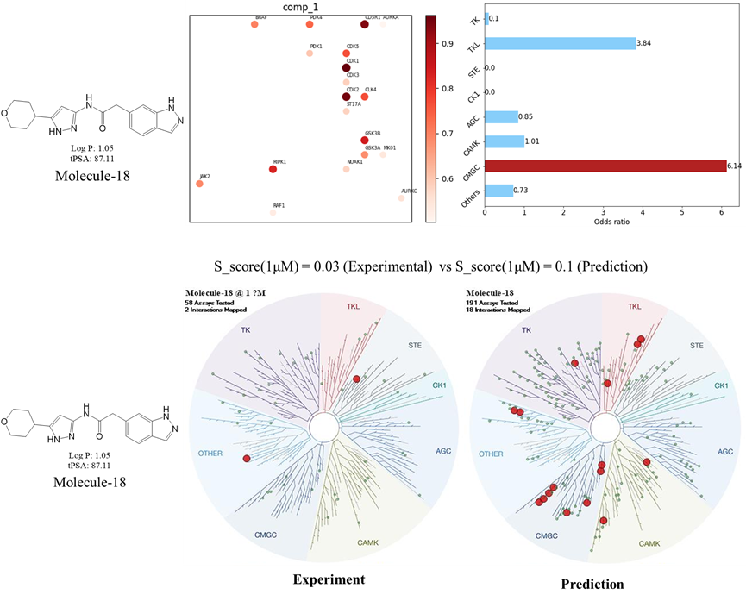

**Figure S4.** Comparison of the kinome selectivity profiles predicted by KinomePro-DL model and experimental results obtained from Eurofin KINOMEscan of Molecule 18.

**Figure S5:** Structures of known CDK2 inhibitors from ChemEMBL database with highest similarity compared to hit compounds 11 (a) and 18 (b). Numbers listed for each compound were similarity values obtained by molecular fingerprints using RDKit.

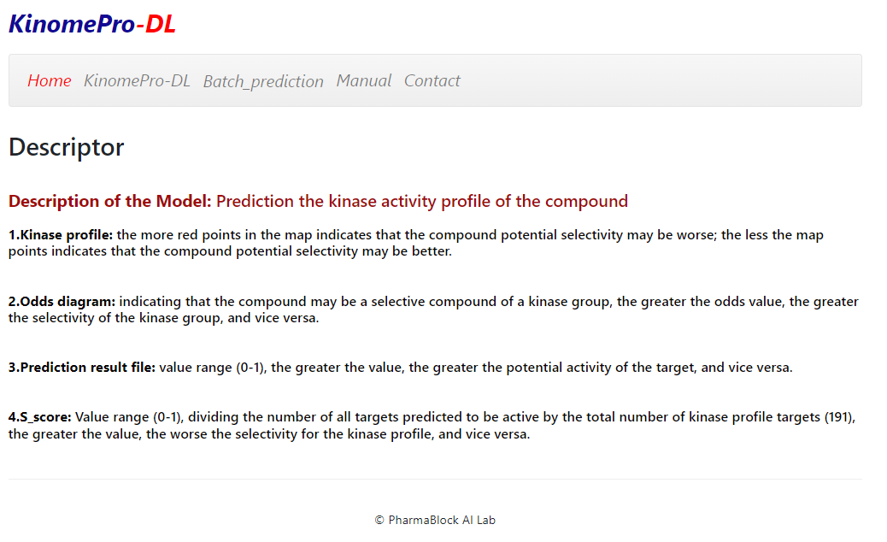

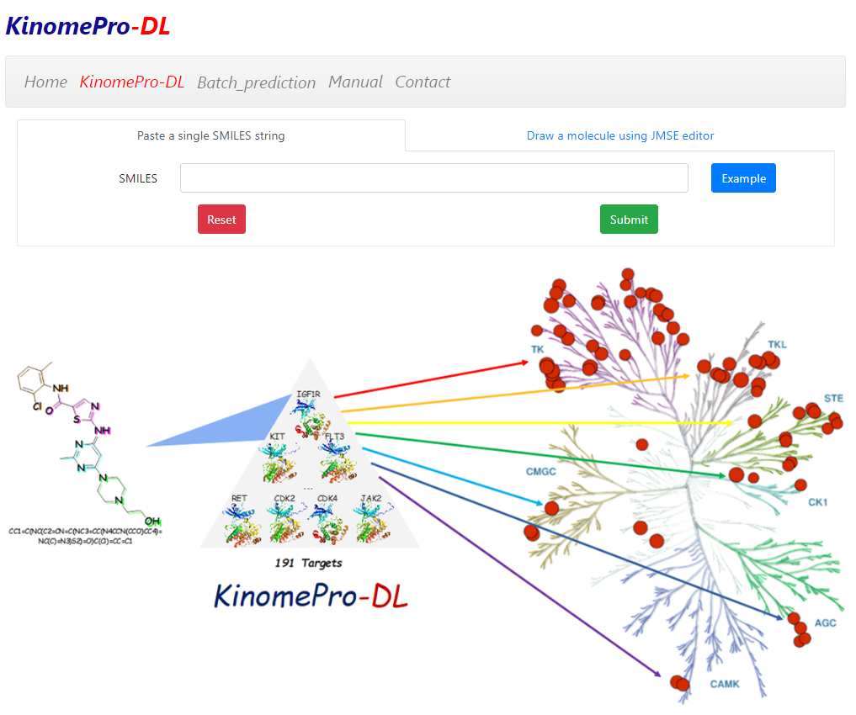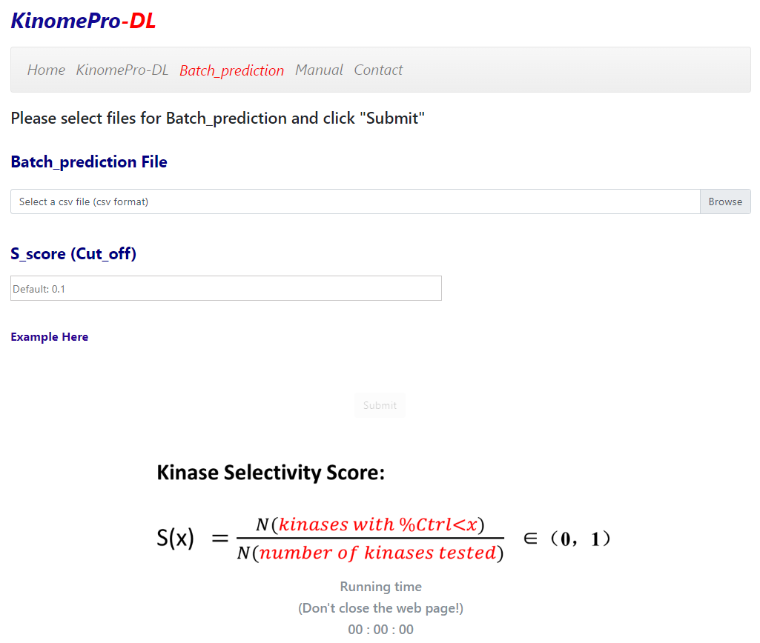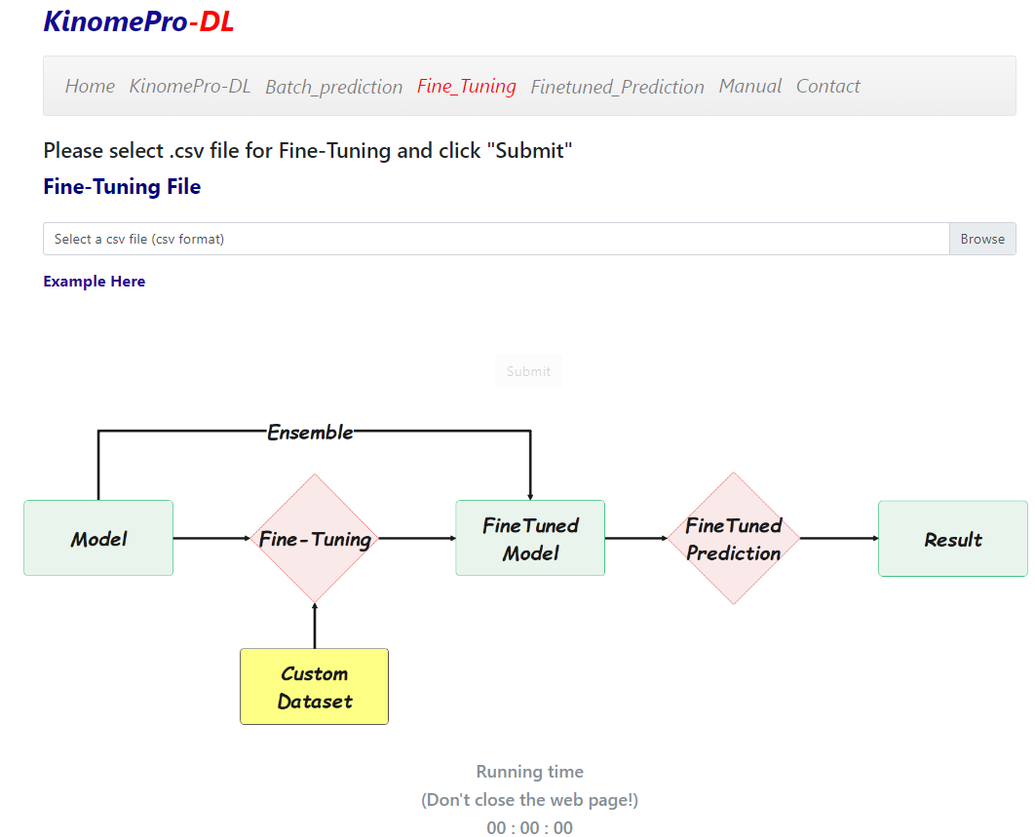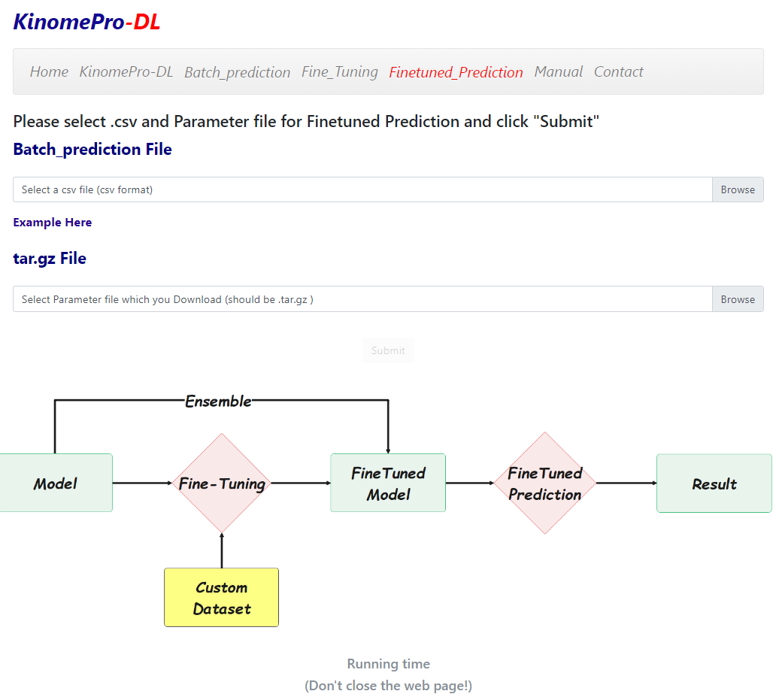

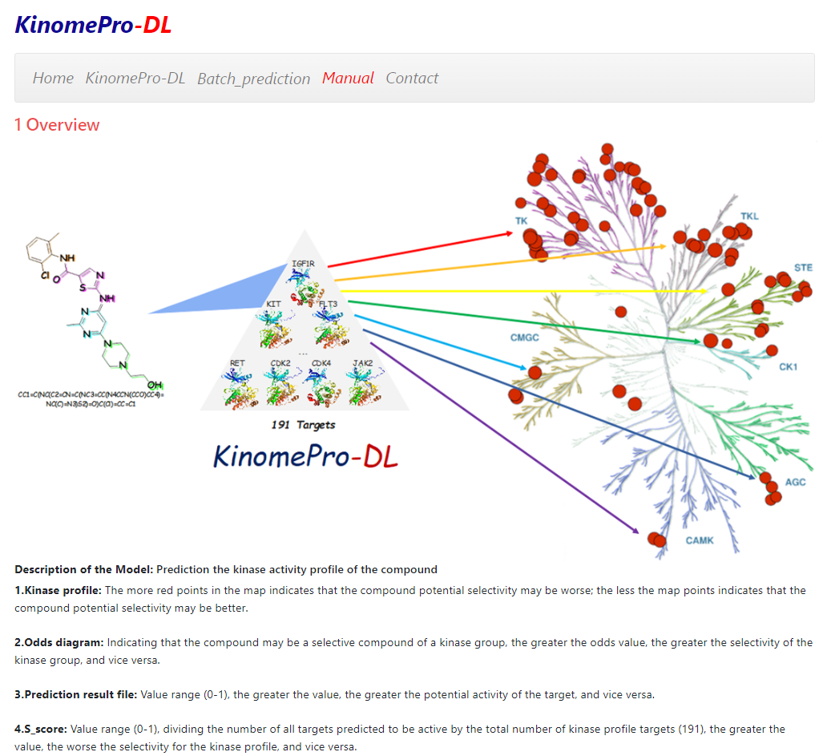

**Figure S6:** Screenshots of representative webpages of KinomePro-DL web server tool, including Homepage, Single molecule prediction, Batch prediction, Fine-tuning, Finetuned Prediction module, and Prediction by manually drawing structures.